LAPORAN PRAKTIKUM – REPETATION FOR
Laporan ini disusun untuk memenuhi Tugas Kelima Praktikum Algoritma & Pemrograman

Dosen Pengampu : Dr. Ionia Veritawati, S.Si., MT.



Oleh :

Nama : Nayunda Krisna Abi Pasya
NPM : 4524210077

PROGRAM STUDI TEKNIK INFORMATIKA FAKULTAS TEKNIK
UNIVERSITAS PANCASILA 2024/2025

Program Contoh For

Source Code #include
<iostream> using namespace std;

int main(){ for (int angka = -5; angka <= 5; angka++){ cout << angka << endl;
}

return 0;
}

SS Hasil Running Program
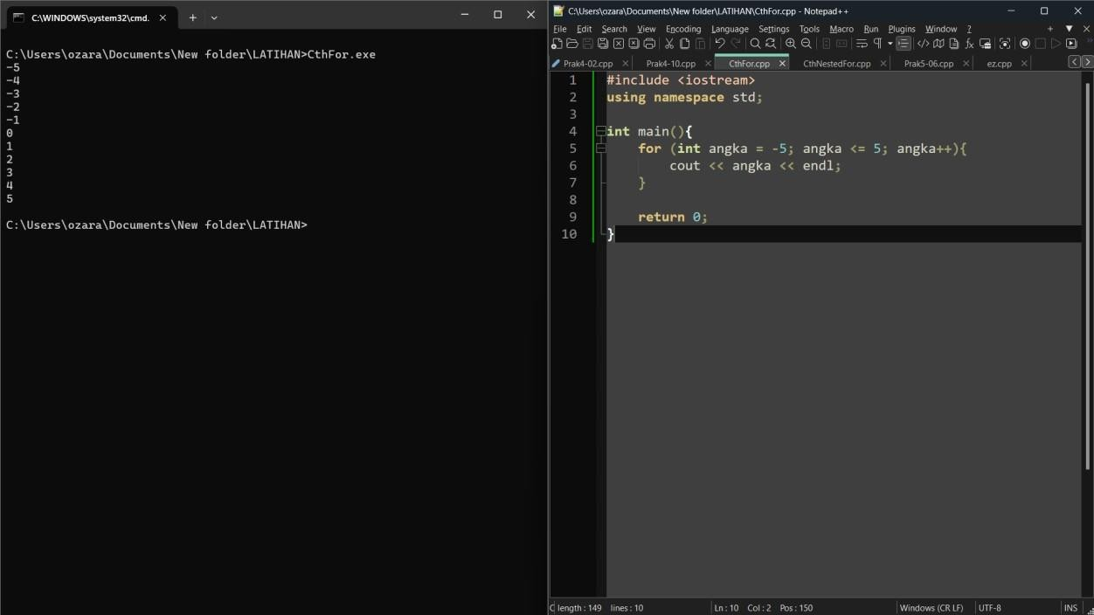

Pseuducode

Deklarasi Angka : int

Deskripsi
For (angka = -5; angka <= 5; angka++) Print (angka)
endfor

BAHASA ALAMI

- Mulai
- Untuk angka = -5, selama angka <= 5, maka tampilkan variabel angka, lalu angka++
- selesai

FLOWCHART
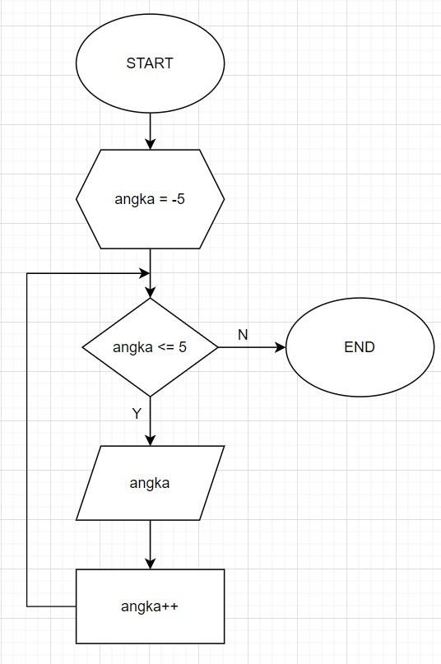

Program Contoh Nested For

Source code #include

<iostream> using namespace std;

int main(){

int n = 0;

for (int k = 1; k <= 4; k++){ for (int i = k; i <= 6; i++){
n = n+5;

cout << "Nilai N = " << n << endl;

}

}

return 0;

}

SS Hasil Running Program
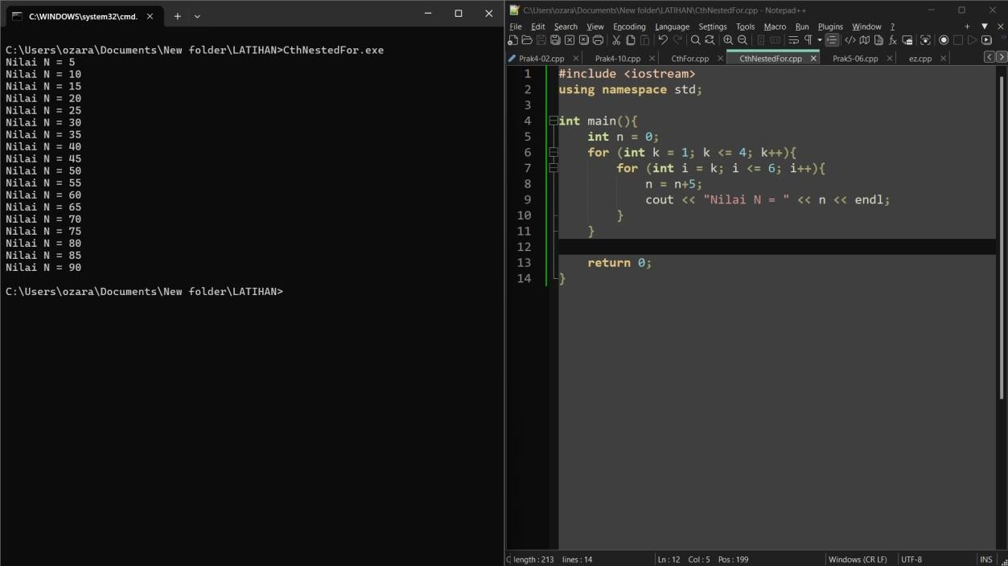

Pseudocode

DEKLARASI VARIABEL
N = 0, k, i : int

DESKRIPSI
For (k = 1; k <= 4; k++)

For (I = k; I <= 6; i++) N = n + 5
Print (n)

Endfor endfor

Bahasa Alami

- Masuk
- N = 0
- Untuk k = 1, selama k <= 4, lalu k++
- Untuk I = k, selama I <= 6, lalu i++
- N = n+5
- Tampilkan variabel n
- selesai

Flowchart
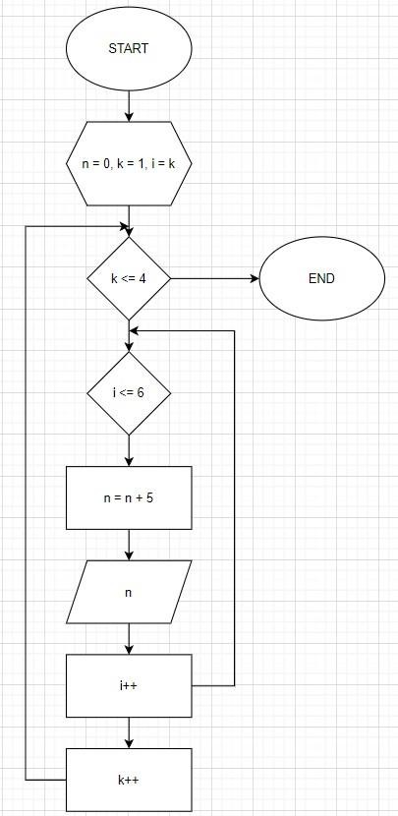

Manual
k = 1:

i = 1:
n += 5 → n = 0 + 5 = 5
i = 2:
n += 5 → n = 5 + 5 = 10
i = 3:
n += 5 → n = 10 + 5 = 15
i = 4:
n += 5 → n = 15 + 5 = 20
i = 5:
n += 5 → n = 20 + 5 = 25
i = 6:
n += 5 → n = 25 + 5 = 30

k = 2:

i = 2:
n += 5 → n = 30 + 5 = 35
i = 3:
n += 5 → n = 35 + 5 = 40
i = 4:
n += 5 → n = 40 + 5 = 45
i = 5:
n += 5 → n = 45 + 5 = 50
i = 6:
n += 5 → n = 50 + 5 = 55

k = 3:

i = 3:
n += 5 → n = 55 + 5 = 60

i = 4:
n += 5 → n = 60 + 5 = 65
i = 5:
n += 5 → n = 65 + 5 = 70
i = 6:
n += 5 → n = 70 + 5 = 75

k = 4:

i = 4:
n += 5 → n = 75 + 5 = 80
i = 5:
n += 5 → n = 80 + 5 = 85
i = 6:
n += 5 → n = 85 + 5 = 90

